PROVIDENCE HOUSING AUTHORITY

RESIDENT SERVICES
BOARD OF COMMISSIONERS SUBCOMMITTEE MEETING
Major Projects Report-COVID 19
July 23, 2020

RESIDENT SERVICES DEPARTMENT

COVID 19 Updates:
The RSD’s approach to COVID 19 has been to serve Residents through an interdepartmental approach.
- Emergency Resident Outreach Log (EROL)-The EROL targeting all public housing residents started at the beginning of the crisis and has evolved with multiple phases. The Outreach was not only a completely new way to outreach to residents, it is a new way to share information collaboratively among departments.
The approach to this outreach and the follow-up outreach phases continues to be; to state the purpose of the outreach, create teams by identifying staff across departments to participate, create a standard operating procedure (SOP) that aligns with the purpose of the outreach, create consistent messaging for staff to use with a common script, create a tracking spreadsheet that aligns with the questions on the script, and create and update a universal Resource Guide to share with Residents.
PHASE 1 started on Monday, March 20, 2020: All public housing household were called and information on calls and attempted calls were tracked, in addition to other indicators.
PHASE 2 all public housing resident calls were completed by Friday, April 24, 2020. The Property Management staff was asked to input data and update the public housing software system (HAB) with the contact information collected from the resident survey including the main phone, second phone, emergency contact and email.

PHASE 3 The PHA mailed outreach questions to the residents not contacted through calls. Residents had the option to answer questions on-line through a doodle poll or by returning a paper copy to the office. PM staff is updating information into the log and into HAB. PHASE 3 outreach is approximately 91%. This log is where the Food delivery is tracked. See the table in Food Task Force and Delivery Service.

PHASE 4 the PHA began work on the Leased Housing Outreach Log was on May 8th. RSD staff who had also made the Public Housing calls, called Section 8 participants to share important resources and gather similar information. Staff are also asking, after consultation with Legal Counsel about whether individuals would be willing to self-report positive cases.
PHASE 5: The Leased Housing Reps identified those on their caseload not contacted with an initial call and mailed outreach questions to the Leased Housing participants. Leased Housing participants will have the option to answer questions on-line through a doodle poll or by returning a paper copy to the office. LH staff will update information into the log and into HAB. As of June 81%, of Leased Housing and 37% PBV participants had been contacted.
PHASE 6 continuous improvement: The Office of Strategy and Development identified CallMax as the vendor/system to do mass callings to developments on a variety of issues including but not limited to; FM operations information, COVID testing at Carroll Tower, Food delivery at Codding Court, or future topics such as voter registration reminders.
PHASE 7: Identify and outreach to potential partners to support food delivery and COVID testing.

Additional Resident Outreach:
- PHA established its own COVID 19 Hotline: Through a hotline where Residents can self-report and the PHU log, the PHA staff can follow-up and share or find additional resources to help Residents adhere to their quarantine. The information in this document is confidential. This tracking sheet is a shared document with Directors, who are using the information to ensure staff safety. Resident Service staff has been assigned to check the tracking sheet every half hour, to update information, and offer additional supports to Residents on the COVID 19 positive list. A Standard Operating Procedure has been created, so that during this check in, if there is a new person added, the RSD staff will reach out to the Resident with a series of questions that the resident can voluntarily answer regarding time of quarantine and any additional supports the resident may need.
- Food Task Force and Delivery Service –This interdepartmental project relied on input and leadership from Facilities Management for production and distribution, Property Management for information on individual cases of need, OSD for funding from Rhode Island Foundation, Finance for procurement and funding management, Resident Services for resident outreach, and distribution. Two Standard Operating Procedures have been created; one for the creation of the Food Task Force, and one for the Distribution.
Description of delivery by month | Number Delivered | Additional details
TOTAL FOR MARCH | 194
TOTAL FOR APRIL PHA SUPPLIED | 560
TOTAL FOR APRIL RIFB SUPPLIED | 165
TOTAL FOR MAY PHA SUPPLIED | 524
TOTAL FOR MAY RIFB SUPPLIED | 187
TOTAL FOR MAY FROZEN MEALS(CITY) | 462
TOTAL-TO-DATE FACE MASKS | 174 | Dexter Manor
TOTAL FOR JUNE PHA SUPPLIED | 504
TOTAL FOR JUNE RIFB SUPPLIED | 184
TOTAL FOR JUNE FROZEN | 624
TOTAL FOR JUNE YMCA (TOTAL) | 293 (296) | Codding Court
FSRI (Be Safe Plus) | 21 | Hartford Tower
Seven Stars Bakery/WBNA | 100 loaves of bread | CC and PV
JULY
Parenti Villa, June 7 (1-3pm) | 37 RIFB (4 left over) | 74 Rolls of TP
Dominica Manor, July 8 (10am-12pm) | 67 RIFB (3 left over) | 134 Rolls of TP
Dexter Manor, July 8 (1-3pm) | 53 RIFB (15 left over) | 106 Rolls of TP
TOTAL TO-DATE PHA SUPPLIED** | 1,782
TOTAL TO-DATE RIFB SUPPLIED** | 693
TOTAL TO-DATE FROZEN MEALS(CITY) | 1,086
TOTAL TO-DATE YMCA* | 185 | Codding Court
TOTAL-TO-DATE FACE MASKS | 204 | Dexter Manor
TOTAL TO DATE FOOD BOXES (PHA/RIFB) | 2,475
**All DELIVERIES made by PHA staff *PHA staff assisted delivery

Other Food Programs:

- Frozen meals from the City of Providence: PM staff picked up an additional 900 meals to distribute.
- Sodexo: Tuesdays and Fridays from 11am-2pm at 50/40 Laurel Hill Ave parking lot 2 meals a day for 3 days for children under 18 years old
- Family Service of RI (FSRI): Be Safe Plus program delivered 21 boxes of food, and cleaning supplies to Hartford Tower. In July, we will collaborate a delivery at Dominica Manor. To date, 12 Residents have registered for the Be Safe Plus program. At Dexter Manor 7 Residents have registered for this program

Program Updates:
4. Jobs Plus Providence (JPP) Program
- HUD Jobs Plus Intensive Outreach:
  - To date, 367 residents have enrolled in the JPP program.
  - Property Managers in MH and HP are starting their JPP JPEID Interim Interviews. We implemented new strategy to expand our financial coaching services and aid those with a financial hardship. Residents that have a significant increase in their rent due to the end of JPEID will be referred to our Financial Coach (FC). A spreadsheet was created to keep track of referrals and the residents' progress.
  - Unemployment Insurance and Benefit Applications

- Partnerships
  - Providence Public Library (PPL) – is supporting on-going computer literacy through on-line teacher guided learning.
  - Progreso Latino-is supporting adult HSE learning through on-line teacher guided learning
  - Young Voices-is developing a distance learning program for their summer youth leadership

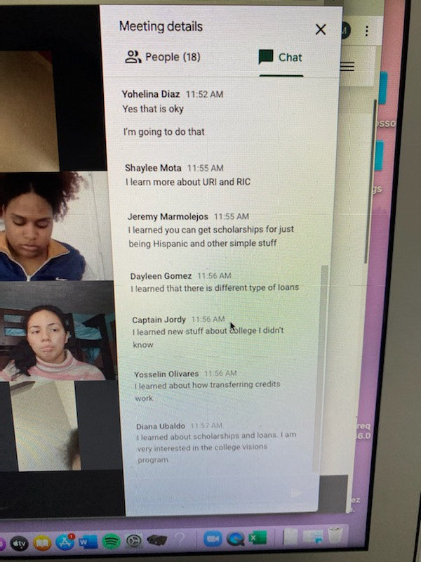
- One Providence Summer Youth Internship
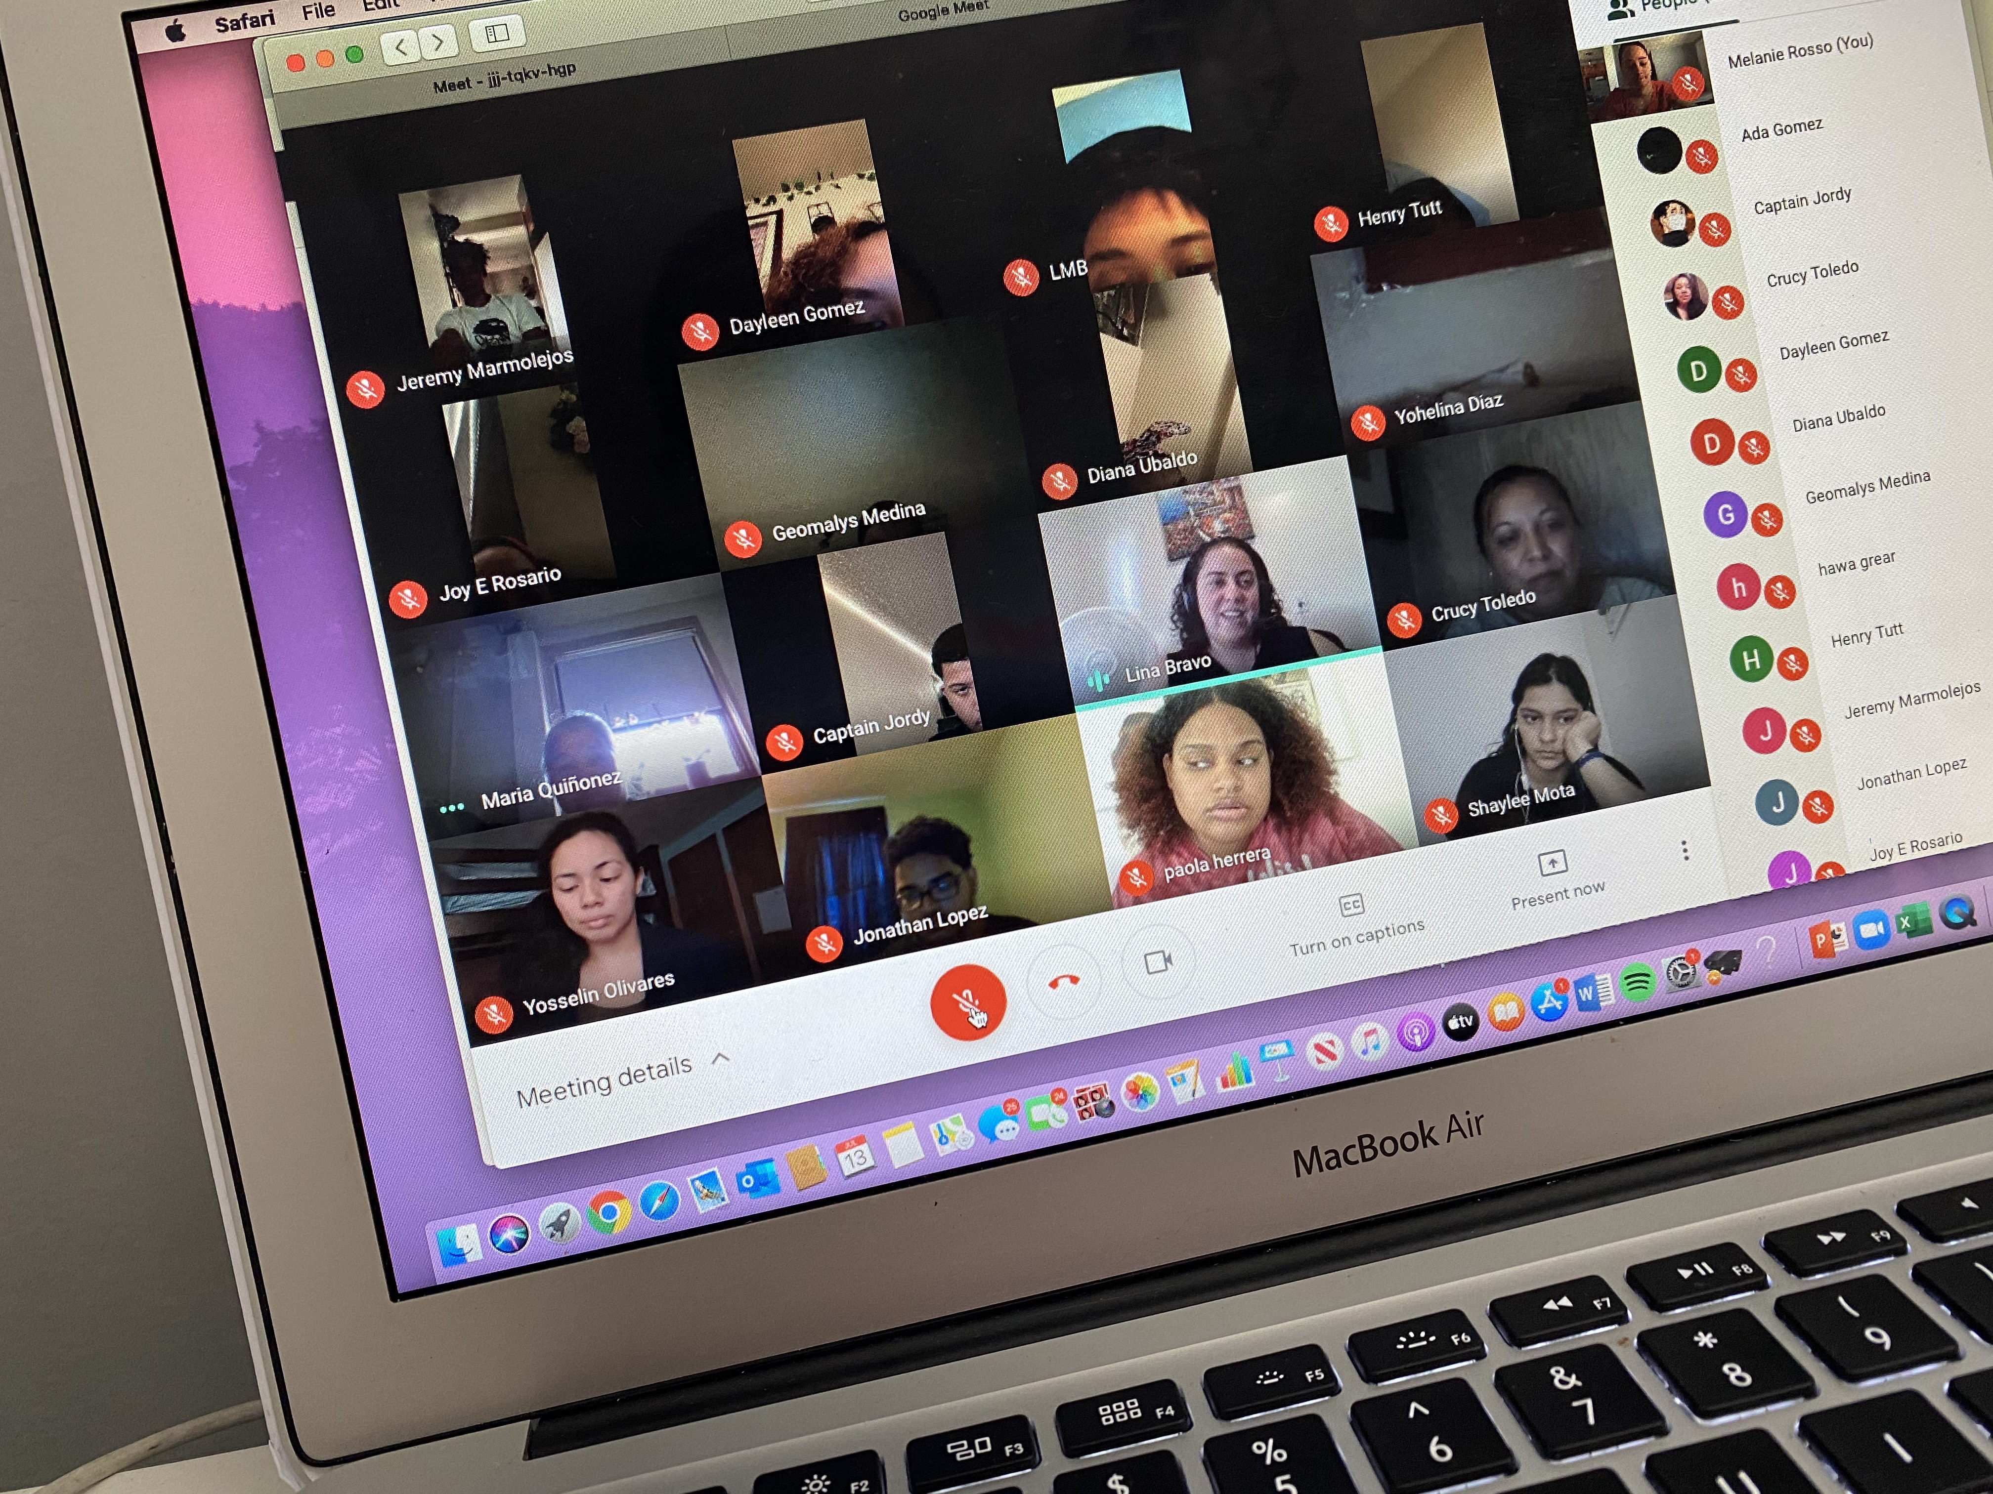

  - The team created an alternative on-line programming for summer learning. The program runs 6 weeks, 15 hours per week starting on 7/06/2020 and will end on 8/14/2020. Staff is working in groups and one-on-one through Zoom and Google Meet to have youth develop individualized projects for career exploration. Youth will complete the online talent assessment (formerly the Clifton StrengthsFinder) to discover what they naturally do best, learn how to develop natural talents into workplace strengths. In addition, youth will participate in a 3-part Strengths series online that will be facilitated by a Gallup Consultant. These strengths-based development sessions help the youth to increase their understanding of Strengths-based development and increase their awareness and appreciation about each of their individual and collective talents and strengths. The curriculum will also include career exploration and assisting youth with creating a resume.
  - The photos in the beginning of this section are from the Providence Public Library (PPL) classes for our summer youth-at no cost to the PHA. Part of the learning protocol is that youth have their camera’s on during the session to check in on engagement. The classes are twice a week and by the end of the summer they will have at least 2 NorthStar certifications.

5. FSS
- Remote services, with check in calls every week or every two weeks depending on client need.
- Update HUD waiver for FSS program
  - There have been 3 terminations
    - 2 positive terminations
    - 1 negative termination
  - There have been 2 extension request due to COVID

- FSS Success story

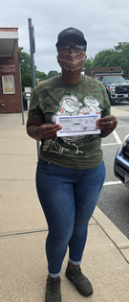

Candia is our prized participant, as she is taking the largest escrow check in the history of Providence Housing Authority. Due to her hard work and dedication to the FSS program Candia’s escrow check totaled at $42,348.43. She has begun the process of cleaning her credit by paying off her debt thus increasing her credit score. With her escrow money she plans on paying off her car loan and putting down a deposit towards her 1st home.

6. Resident Service Coordinator (RSC) Program
- Remote support to caseload clients
- Unemployment Application support
- Family RSC’s are continuing to review the recent HUD data guide and establishing a draft Standard Operating Procedure (SOP) for data entry into the HUD InForm tracking tool.
- Strong Families event – on hold
- Spring Health fairs - on hold

7. Wellness Coordinator
- Remote services-including on-line group meetings. The Hartford Tower group meets on Thursdays and there have been 5 consistent participants.
- Resource list sent to all Wellness Center clients that includes zoom links to AA and NA meetings.
- Intensive follow up on a weekly basis
- New data entry responsibilities in the Rhode Island Quality Institute (RIQI) database KnowMyHealthRI for the Government Performance and Results Act (GPRA) assessment for BHDDH for both Providence Housing Authority and PawtHA Wellness Coordinators.

8. VOCA Coordinator
- 158 Residents have been served by this program to-date.
- Continuous review of weekly Security Reports, to offer remote services
- Leading development of a process for reviewing Security Reports with Wellness Coordinator for a coordinated and comprehensive approach to Resident Outreach.
- Intensive follow up on a weekly basis
- Has encouraged participation in on-line group meetings
- Development Virtual Self-Care workshop for VOCA clients to start in July
- Virtual Diversity presentation to youth in the One Providence Summer Youth program

This week a PHA Resident came forward to thank staff for creating the village needed to remove her from a toxic marriage of 20 years. The VOCA Coordinator collaborated to help her together with all PHA staff across departments (Maintenance, Property Management, Resident Services, Wellness Resource Center) who were involved in this success. She was in an abusive relationship for 20 years that affected her mental health, her physical health, and led Alcohol/Substance abuse. For the past 5 years she has walked with a limp and cane. She was transferred to new unit, participated in Wellness Groups, met with the Community Health Worker to organize health appointments, met with the Wellness Coordinator to work on her addiction and mental health issues, met with Resident Service Coordinator for services such as; food stamps and health insurance. She has not used a cane in over 2 months. She was scared to be lonely only to discover the relationship was holding her back from her blessings. She still has a long road ahead of her but is grateful to now live in her peace, she has repaired broken relationships and is now focused on one day going back to work with ambitions to work as an advocate.

9. Adult Education Program
- Genesis Center-conducting on-line distance learning for Adult Basic Education classes and phoneline conferences to work collaboratively on outreach and recruitment for programs.
  - To date 148 students have been served in classes held onsite at the PHA.
  - The Internal Career Advancement Program (iCAP) program continued their ESL classes virtually. Students meet via Google Meet every Monday, Tuesday, and Wednesday.
  - While classes continued, due to the safety of the students Urban Greens Co-Op Food paused their internship program. They are scheduled to resume in July.

10. VITA
- On hold-deadline extension until July 15 for filing
- Federal Hill House is still offering in-person services.

11. Financial Coach/Homeownership Program
- First Time Homebuyer Fair-on hold
- Unemployment Application support
- Restructuring the FOC program to offer Financial Coaching more broadly to various residents. Pilot project in development to make strategic referrals to the Financial Coach for Residents with a payment plan resulting from the COVID 19 impact. The FC is working with 11 resident’s one-on-one, reviewing their credit, and establishing a livable/manageable budget.

12. RSD Partnerships
- Boys and Girls Club-The Boys and Girls Club is planning on offering summer programming only at one of their 3 sites in response to program delivery changes required. Due to emergency funding from RIDE, the BGC will be offering programming to support 26 PHA youth at Chad Brown and Manton Heights during the month of August.
- Head Start-Setting up a phone conference to work together to share messaging to Residents for their new program delivery.
- Family Service of Rhode Island Be Safe Plus program - a service providing deliveries of fresh foods and cleaning supplies to elderly and disabled residents. Boxes of fresh foods along with safety supplies like masks, hand sanitizer, toilet paper and more delivered to residents who register with The Point. We are piloting a collaboration of messaging registering for this program together with our food delivery at Hartford Tower.
- Centro Innovacion Mujer Latina -food delivery and mental and behavioral health services for elderly Community members.
- Sojourner House-development of the partnership to streamline access to shelter services
- Other Partnerships as described in Jobs Plus

13. HUD Highlight:
Nancy Smith-Greer, the Director of the Rhode Island HUD office, organized a congratulatory video call in conjunction with Home Ownership Month with Regional Administrator, David Tille on Monday, June 29th with Julie Piccolo and Nicole Morillo for the $15,425 Housing Counseling grant the PHA was awarded.
Nicole shared success metrics for the HUD Housing Counseling Funds year-to-date through April 2020 we have been able to serve: 109 YTD households, 80 YTD completed financial workshops , 32 YTD completed Pre-purchase home buyers workshops, 4 YTD households purchased a home.
The feedback after the call was that Regional Administrator Tille was very pleased and thought everything went well. He enjoyed hearing about the work you are doing and the successes you are having. They would like to highlight the data and achievements in either an upcoming HUD newsletter or a HUD Happenings article.

OFFICE OF STRATEGY AND DEVELOPMENT
Funding Updates: We were unsuccessful in our applications to the Central Providence Health Equity Zone and the United Way of RI, each of which were for $25,000 to support expanded capacity in Workforce development. We submitted a proposal in late June to the Housing Authority Insurance Group for funding to support a vulnerability scan for the PHA’s computer networks, and a decision on that is pending. Our request for a third year of VOCA funding, which would begin March 2021, is pending. The request is for $159,802, compared to the current year budget of $141.337.
OSD is also finalizing a request to FEMA to offset emergency response costs for COVID-19 that came into place before CARES Act funds were available. We anticipate if all expenses are approved that we will get 75% of the total request, which comes out to $48,811.
We are still waiting to hear on the AARP Community Challenge grant request to support the garden and other outdoor improvements at Kilmartin Plaza and on a $2,000 request to the Providence Rotary Foundation to support tablets for youth in the PHA’s summer youth employment program.
Resident Advisory Board: The OSD continues weekly zoom check ins with members of the RAB from across nine developments, and held a meeting with the full RAB on Wednesday, July 15. During that time we had Family Service of RI present on the Be Safe Plus program mentioned above, and residents from several buildings have already begun promoting the program to neighbors. Commissioner Doggett is planning to work with OSD to use this program as an opportunity to promote some community building at Manton Heights as a step towards starting a tenant association. At the July 15 RAB meeting we also discussed the potential of using community and building cleanup efforts as a form of community organization.

We have worked to address issues identified by RAB members on an ongoing basis, such as:
• Concerns about residents and visitors not taking mask wearing seriously;
• Concerns about residents in family developments not taking seriously social distancing requirements by hosting gatherings in excess of state limitation;
• Concerns about residents improperly disposing of trash and illegal dumping by outside persons at family developments;
• Ways to make Covid-19 testing available to residents in elder/handicapped developments;
• Residents struggling with mental health and addiction issues; and
• Fireworks and parties.

Support for Leased Housing Residents and Landlords: Together with the Leased Housing Department, OSD is working to hire a new Americorps member who will begin work in September through the Accessing Home program we participate in. This member will work to provide housing search assistance and connection to services for hard to house tenants receiving vouchers under the PHA’s VASH and Mainstream voucher programs, both of which largely serve individuals and families experiencing homelessness. The member will also work with OSD and LH staff to increase outreach to landlords who do and do not participate in the Section 8 program to seek more involvement and get feedback on how to make the program more attractive to landlords – with a goal of supporting more choice and housing opportunity for Section 8 tenants. More updates to come.
Other Resident projects: OSD continues to support the community garden project at Sunset Village. OSD staff worked with the development’s RAB representative and a team of resident volunteers to design and plant two flower beds at the development. The beds were planted on June 16 and residents relate that continuing to tend the gardens in July provided an opportunity to experience community in the midst of social distancing and a decreased sense of isolation.
We are in discussion with the African Alliance of RI on continuing their support for resident garden projects at various PHA developments – in particular Chad Brown, where tenants have continued their garden project with limited staff support this year, and Kilmartin Plaza.

